**Explanation:**

Mateusz Kus for a course - Object Oriented Programming – McMaster Univeristy

This is a program to play the game: Rock Paper Scissors Spock Lizard

Rules of the game are:

- Spock beats scissors and rock, but loses to paper and lizard.

- Lizard beats Spock and paper, but loses to rock and scissors.

- Rock beats scissors and lizard, but loses to paper and Spock.

- Paper beats rock and Spock, but loses to scissors and lizard.

- Scissors beats paper and lizard, but loses to rock and Spock.

The program has two players and each of them produce a random outcome, i.e., Rock, paper, scissor, spock, or lizard.

Random number generator will select options:

1 - Spock

2 - Lizard

3 - Rock

4 - Paper

5 - Scissors

Based on each player’s outcome, winner is determined.

Score is displayer after each round, and summed up to show the total score after few rounds of the game. Game can be replayed as many times as user wants.

Program is constructed as follows:

**CODE:**

#importing random to be able to use in the function select_random_value()

import random

#naming variables and assigning names

ROCK = 'Rock'

PAPER = 'Paper'

SPOCK = 'Spock'

SCISSORS = 'Scissors'

LIZARD = 'Lizard'

#setting zero scores for the start of the game

player1_score = 0

player2_score = 0

#main function that runs other functions

def main():

'''

Main function of the game that starts all the other functions.

Returns

-------

None.

'''

#declaring global variables for score counting in local scope

global player1_score

global player2_score

#randomly selecting values for the game (Rock, Paper, etc.) for each player

player1 = select_random_value()

player2 = select_random_value()

#printing randomly selected values on the screen

print('\nPlayer one selected: ' + player1[1])

print('Player two selected: ' + player2[1])

#selecting the winner based on the selection and adding points to each players score

winner = selecting_winner(player1[1], player2[1])

#new scores for each player

player1_score = winner[0]

player2_score = winner[1]

#printing current score on the screen

print(f'\nCurrent score is\n---------------------------\nPlayer 1: {winner[0]}\nPlayer 2: {winner[1]}')

# asking player to play again or not. If yes selected, game will restart, otherwise it will say thanks and exit.

play_again(input('Press \'y\' and ENTER if you want to play again, otherwise just press ENTER: '))

#function to select random value and assign text

def select_random_value():

'''

Random selection of option from 6 possibilities for each player in the game.

Returns

-------

random_value : int

description : str

'''

description = ''

random_value = random.randint(1, 5)

if random_value == 1:

description = SPOCK

if random_value == 2:

description = LIZARD

if random_value == 3:

description = ROCK

if random_value == 4:

description = PAPER

if random_value == 5:

description = SCISSORS

return random_value, description

#function that decides who wins and prints output

def selecting_winner(player1_selection, player2_selection):

'''

Parameters

----------

Each player's random selection is the input (as string) from available options (Rock, Paper, etc....)

player1_selection : str

player2_selection : str

Returns

-------

Returns the results of another function that calculate scores and adds it to total score (increment_counter())

'''

#declaring global variables for score in the local scope.

global player1_score

global player2_score

#option for draw if both players selected same option

if player1_selection == player2_selection:

print('It is a draw')

#Options for selecting winner

# SPOCK for player 1

#win

if player1_selection == SPOCK and (player2_selection == SCISSORS or player2_selection == ROCK):

print('Player 1 wins')

return increment_counter(1, player1_score, player2_score)

#loss

if player1_selection == SPOCK and (player2_selection == PAPER or player2_selection == LIZARD):

print('Player 2 wins')

return increment_counter(2, player1_score, player2_score)

# LIZARD for player 1

#win

if player1_selection == LIZARD and (player2_selection == SPOCK or player2_selection == PAPER):

print('Player 1 wins')

return increment_counter(1, player1_score, player2_score)

#loss

if player1_selection == LIZARD and (player2_selection == ROCK or player2_selection == SCISSORS):

print('Player 2 wins')

return increment_counter(2, player1_score, player2_score)

# ROCK for player 1

#win

if player1_selection == ROCK and (player2_selection == SCISSORS or player2_selection == LIZARD):

print('Player 1 wins')

return increment_counter(1, player1_score, player2_score)

#loss

if player1_selection == ROCK and (player2_selection == PAPER or player2_selection == SPOCK):

print('Player 2 wins')

return increment_counter(2, player1_score, player2_score)

# PAPER for player 1

#win

if player1_selection == PAPER and (player2_selection == ROCK or player2_selection == SPOCK):

print('Player 1 wins')

return increment_counter(1, player1_score, player2_score)

#loss

if player1_selection == PAPER and (player2_selection == SCISSORS or player2_selection == LIZARD):

print('Player 2 wins')

return increment_counter(2, player1_score, player2_score)

# SCISSORS for player 1

#win

if player1_selection == SCISSORS and (player2_selection == PAPER or player2_selection == LIZARD):

print('Player 1 wins')

return increment_counter(1, player1_score, player2_score)

#loss

if player1_selection == SCISSORS and (player2_selection == ROCK or player2_selection == SPOCK):

print('Player 2 wins')

return increment_counter(2, player1_score, player2_score)

#in case there is a draw, calling other function to count scores

return increment_counter(0, player1_score, player2_score)

#increment counter function to count score of each player based on round results

def increment_counter(winner, player1_current_score, player2_current_score):

'''

Parameters

----------

winner : int

supply number of the winner 1 for player 1 and 2 for player 2, 0 if this is a draw

player1_current_score : float

supply current score for player 1

player2_current_score : float

supply current score for player 2

Returns

-------

player1_new_score : float

returns new score of player 1

player2_new_score : float

returns new score of player 2

'''

#if player one wins

if winner == 1:

player1_new_score = player1_current_score + 1

player2_new_score = player2_current_score

#if player two wins

elif winner == 2:

player1_new_score = player1_current_score

player2_new_score = player2_current_score + 1

#if it is a draw

else:

player1_new_score = player1_current_score + 0.5

player2_new_score = player2_current_score + 0.5

#new scores for each player after the round

return player1_new_score, player2_new_score

#function the alows to restart the game

def play_again(decision):

'''

Parameters

----------

decision : str

Returns

-------

None.

'''

if decision == 'y':

main()

else:

print('--------------------------------------\nThank you for playing, see you next time')

# Calling main function

main()

**OUTPUT**

**Starting the game:**

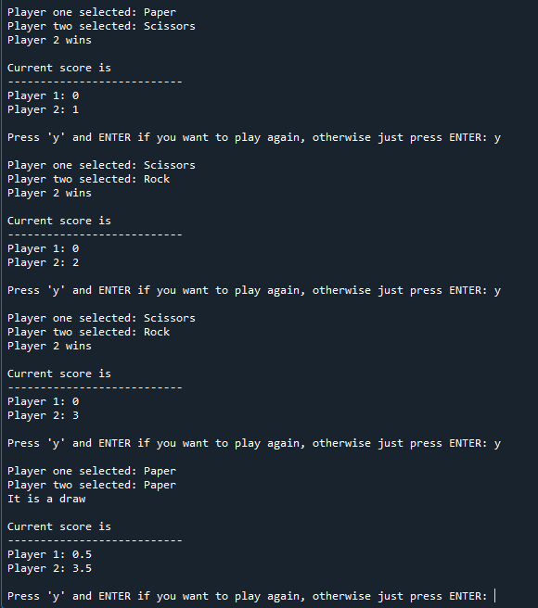

**Continuing the game and then finishing**

